**Step 1: Drawing Basic Shapes With Python Turtle**

1. Create an new Repl by selecting the **“Python with Turtle”** language / environment.

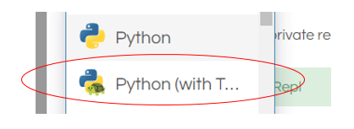

1. Begin all of your turtle programs with the following code to create a “pen”:

import turtle

myPen = turtle.Turtle()

1. Review the following chart for a list of Turtle commands.

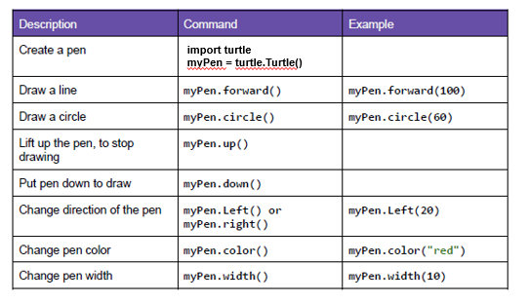

1. Use the following program to draw a red square.

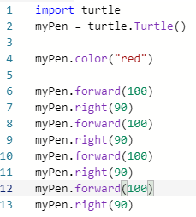

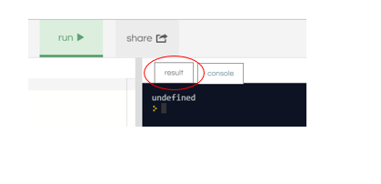

1. Switch to the “Result” window to see the square.
2. Create a program to draw any one of the shapes “b”, ”d”, or “e” shown in the figures below.   
   Provide a listing of your program code.

import turtle

myPen= turtle.Turtle()

myPen.color("red")

myPen.right(45)

myPen.forward(100)

myPen.up

myPen.right(180)

myPen.forward(50)

myPen.right(90)

myPen.forward(50)

myPen.right(180)

myPen.down()

myPen.forward(100)

1. import turtle

myPen = turtle.Turtle()

myPen.color("red")

myPen.forward(200)

myPen.right(90)

myPen.forward(100)

myPen.right(90)

myPen.forward(200)

myPen.left(90)

myPen.forward(200)

myPen.right(90)

myPen.forward(100)

myPen.right(90)

myPen.forward(200)

myPen.left(90)

myPen.forward(200)

myPen.right(90)

myPen.forward(100)

myPen.right(90)

myPen.forward(200)

myPen.left(90)

myPen.forward(200)

myPen.right(90)

myPen.forward(100)

myPen.right(90)

myPen.forward(200)

1. Create a program to draw any one of the shapes “c”, or “f” shown in the figures below.   
   Provide a listing of your program code.

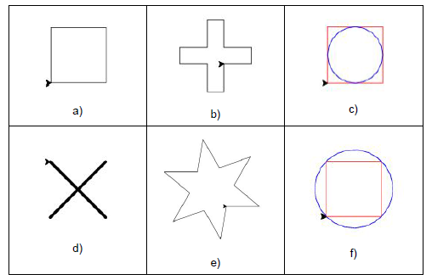

c)

import turtle

myPen = turtle.Turtle()

myPen.color("red")

myPen.forward(200)

myPen.right(90)

myPen.forward(200)

myPen.right(90)

myPen.forward(200)

myPen.right(90)

myPen.forward(200)

myPen.right(90)

myPen.up

myPen.right(90)

myPen.forward(100)

myPen.down

myPen.color("blue")

myPen.circle(100)

f)

**Step 2: Christmas / Winter Theme Card**

1. Use your creativity to create a card design using Turtle.
   1. The design must have multiple figures.
   2. The design must have at least two different patterns.
   3. You may repeat patterns.
   4. Provide a listing of your program code.
   5. Provide an image of your program result.

import turtle

myPen = turtle.Turtle()

myPen2 = turtle.Turtle()

myPen3 = turtle.Turtle()

myPen4 = turtle.Turtle()

myPen5 = turtle.Turtle()

myPen6 = turtle.Turtle()

myPen.speed(100)

myPen2.speed(100)

myPen3.speed(100)

myPen4.speed(100)

myPen5.speed(100)

myPen6.speed(100)

myPen.color("brown")

myPen2.color("green")

myPen3.color("green")

myPen4.color("yellow")

myPen5.color("blue")

myPen6.color("red")

myPen.fillcolor('brown')

myPen.begin_fill()

for i in range(1):

myPen.forward(100)

myPen.right(90)

myPen.forward(200)

myPen.right(90)

myPen.forward(100)

myPen.right(90)

myPen.forward(200)

myPen.right(90)

myPen.end_fill()

myPen.up()

myPen.left(180)

myPen.forward(100)

myPen.down()

myPen.color("green")

myPen.fillcolor('green')

myPen.begin_fill()

for i in range(1):

myPen.right(180)

myPen.forward(300)

myPen.left(141)

myPen.forward(200)

myPen.left(80)

myPen.forward(190)

myPen.end_fill()

myPen2.up()

myPen2.forward(45)

myPen2.left(90)

myPen2.forward(105)

myPen2.down()

myPen2.fillcolor('green')

myPen2.begin_fill()

for i in range(1):

myPen2.right(90)

myPen2.forward(150)

myPen2.left(141)

myPen2.forward(200)

myPen2.left(80)

myPen2.forward(190)

myPen2.left(138)

myPen2.forward(150)

myPen2.end_fill()

myPen3.up()

myPen3.forward(45)

myPen3.left(90)

myPen3.forward(210)

myPen3.down()

myPen3.fillcolor('green')

myPen3.begin_fill()

for i in range(1):

myPen3.right(90)

myPen3.forward(150)

myPen3.left(141)

myPen3.forward(200)

myPen3.left(80)

myPen3.forward(190)

myPen3.left(138)

myPen3.forward(150)

myPen3.end_fill()

myPen4.up()

myPen4.forward(45)

myPen4.left(90)

myPen4.forward(50)

myPen4.down()

myPen4.fillcolor('yellow')

myPen4.begin_fill()

myPen4.circle(10)

myPen4.end_fill()

myPen4.up()

myPen4.forward(45)

myPen4.left(90)

myPen4.forward(50)

myPen4.down()

myPen4.fillcolor('yellow')

myPen4.begin_fill()

myPen4.circle(10)

myPen4.end_fill()

myPen4.up()

myPen4.forward(45)

myPen4.left(90)

myPen4.forward(50)

myPen4.down()

myPen4.fillcolor('yellow')

myPen4.begin_fill()

myPen4.circle(10)

myPen4.end_fill()

myPen4.up()

myPen4.forward(45)

myPen4.left(90)

myPen4.forward(50)

myPen4.down()

myPen4.fillcolor('yellow')

myPen4.begin_fill()

myPen4.circle(10)

myPen4.end_fill()

myPen4.up()

myPen4.forward(90)

myPen4.left(90)

myPen4.forward(50)

myPen4.down()

myPen4.fillcolor('yellow')

myPen4.begin_fill()

myPen4.circle(10)

myPen4.end_fill()

myPen4.up()

myPen4.forward(15)

myPen4.right(90)

myPen4.forward(15)

myPen4.down()

myPen4.fillcolor('yellow')

myPen4.begin_fill()

myPen4.circle(10)

myPen4.end_fill()

myPen4.up()

myPen4.forward(15)

myPen4.right(90)

myPen4.forward(15)

myPen4.down()

myPen4.fillcolor('yellow')

myPen4.begin_fill()

myPen4.circle(10)

myPen4.end_fill()

myPen4.up()

myPen4.forward(15)

myPen4.right(90)

myPen4.forward(15)

myPen4.down()

myPen4.fillcolor('yellow')

myPen4.begin_fill()

myPen4.circle(10)

myPen4.end_fill()

myPen5.up()

myPen5.forward(45)

myPen5.left(90)

myPen5.forward(150)

myPen5.down()

myPen5.fillcolor('blue')

myPen5.begin_fill()

myPen5.circle(10)

myPen5.end_fill()

myPen5.up()

myPen5.forward(45)

myPen5.left(90)

myPen5.forward(50)

myPen5.down()

myPen5.fillcolor('blue')

myPen5.begin_fill()

myPen5.circle(10)

myPen5.end_fill()

myPen5.up()

myPen5.forward(45)

myPen5.left(90)

myPen5.forward(50)

myPen5.down()

myPen5.fillcolor('blue')

myPen5.begin_fill()

myPen5.circle(10)

myPen5.end_fill()

myPen5.up()

myPen5.forward(45)

myPen5.left(90)

myPen5.forward(50)

myPen5.down()

myPen5.fillcolor('blue')

myPen5.begin_fill()

myPen5.circle(10)

myPen5.end_fill()

myPen5.up()

myPen5.forward(45)

myPen5.left(90)

myPen5.forward(50)

myPen5.down()

myPen5.fillcolor('blue')

myPen5.begin_fill()

myPen5.circle(10)

myPen5.end_fill()

myPen5.up()

myPen5.forward(15)

myPen5.right(90)

myPen5.forward(15)

myPen5.down()

myPen5.fillcolor('blue')

myPen5.begin_fill()

myPen5.circle(10)

myPen5.end_fill()

myPen5.up()

myPen5.forward(15)

myPen5.right(90)

myPen5.forward(15)

myPen5.down()

myPen5.fillcolor('blue')

myPen5.begin_fill()

myPen5.circle(10)

myPen5.end_fill()

myPen5.up()

myPen5.forward(15)

myPen5.right(90)

myPen5.forward(15)

myPen5.down()

myPen5.fillcolor('blue')

myPen5.begin_fill()

myPen5.circle(10)

myPen5.end_fill()

myPen6.up()

myPen6.forward(45)

myPen6.left(90)

myPen6.forward(280)

myPen6.down()

myPen6.fillcolor('red')

myPen6.begin_fill()

myPen6.circle(10)

myPen6.end_fill()

myPen6.up()

myPen6.forward(45)

myPen6.left(90)

myPen6.forward(30)

myPen6.down()

myPen6.fillcolor('red')

myPen6.begin_fill()

myPen6.circle(10)

myPen6.end_fill()

myPen6.up()

myPen6.forward(45)

myPen6.left(90)

myPen6.forward(50)

myPen6.down()

myPen6.fillcolor('red')

myPen6.begin_fill()

myPen6.circle(10)

myPen6.end_fill()

myPen6.up()

myPen6.forward(45)

myPen6.left(90)

myPen6.forward(50)

myPen6.down()

myPen6.fillcolor('red')

myPen6.begin_fill()

myPen6.circle(10)

myPen6.end_fill()

myPen6.up()

myPen6.forward(45)

myPen6.left(90)

myPen6.forward(50)

myPen6.down()

myPen6.fillcolor('red')

myPen6.begin_fill()

myPen6.circle(10)

myPen6.end_fill()

myPen6.up()

myPen6.forward(15)

myPen6.right(90)

myPen6.forward(15)

myPen6.down()

myPen6.fillcolor('red')

myPen6.begin_fill()

myPen6.circle(10)

myPen6.end_fill()

myPen6.up()

myPen6.forward(15)

myPen6.right(90)

myPen6.forward(15)

myPen6.down()

myPen6.fillcolor('red')

myPen6.begin_fill()

myPen6.circle(10)

myPen6.end_fill()

myPen6.up()

myPen6.forward(15)

myPen6.right(90)

myPen6.forward(15)

myPen6.down()

myPen6.fillcolor('red')

myPen6.begin_fill()

myPen6.circle(10)

myPen6.end_fill()

